

**The future of health and safety**

Moving beyond zero



How to move beyond zero

#### Consider safety as an outcome of business culture and strategy rather than a process

* Rethink the language around health and safety to drive powerful conversations
* View employees as the solution, not the cause
* Give employees the power and opportunity to be part of the process
* Be open to making mistakes and learning from those mistakes
* Think creatively and be open to new ideas
* Make the connections between health and safety, and productivity and efficiency
* Embed health and safety in strategic leadership thinking
* Establish trust

2 **|**

# Overview

Zero harm has been a controversial concept in workplace health and safety for some time but, whatever its merits or flaws, the model has been an important stepping stone in encouraging people to think about safety, how it is applied and managed in their workplaces, and whether corporate aims are measurable and reporting is accurate.

It is now time to build on the lessons of zero harm and think about workplace health and safety afresh. It is time to take the next step, or maybe another one after that. This paper takes a new view, EY’s concept of

Plus One.

Workplace safety regulators, safety professionals and corporate leaders often say they want to send people home from work in the same state they came to work. We believe that people should go home safe and healthy while also satisfied from a good day’s work and proud of what they have achieved.

The focus on reducing worker harm to as low as possible, if not zero, is an established principle of work health and safety management and reflects a core business value. But the management of health and safety should not be static. Recently many business and safety professionals, particularly in Australia, have begun to challenge the established health and safety “order” to reassess and rethink safety management practices. It is necessary to step forward to a new, more relevant, effective way of managing safety.

In preparing our report, EY has undertaken extensive research and sought input and comment from thought leaders in the safety industry.

# A more useful safety approach — Plus One

Andi Csontos, EY Australia’s Health, Safety and Environment (HSE) Partner sees health and safety risk on a scale of minus one to plus one, from impact to opportunity and positive contribution. This new paradigm is outlined in the diagram below:

**Plus One**

**-1**

**Harm**

###### 0

**Zero harm**

**+1**

**Plus One — moving beyond zero**

Illness and injury viewed as

having negative impact on workers and business

Traditional driver for HSE

Aimed at preventing illness and injury Premise that zero illness and injury

is sufficient

Risk viewed a negative impact

Feel good initiatives to “do the right thing”

New driver – healthier, stronger, smarter, better trained people

Improve productivity, efficiency and effectiveness

Improve health and wellbeing

Safety part of total employee value proposition and business agenda

Recalibrated language

Robust and strategic leadership Demonstrated return on investment

**The future of health and safety** Moving beyond zero **|** 3



# People as integral to the process

According to John Green1, Health, Safety, Environment and Quality Director, European Hub at Laing O’Rourke, people are traditionally seen as a risk to control in organisations. He says, “They are controlled by limiting their choices and behaviours or by placing constraints between them and the actual work. People are responsible for all your problems and if we could only get them to follow the perfect systems that we have created then all would be well”.

Green asks, “What would happen if we saw people as part of the solution? Why can’t we take little steps by allowing projects to perform micro experiments pushing the boundaries of safety by trying new things and not doing old things.”

Sidney Dekker2, a prominent researcher and advocate of the positive approach to health and safety, provided much of the theoretical basis to Green’s advocacy.

Dekker’s challenges to business thinking on safety are best summarised in the diagram below:

Many of the elements of Dekker’s “new view” of safety echo some of the recent political discussion about managerial agility, corporate vision, the importance of innovation to staying relevant and continuing to drive business outcomes. Beyond this, there is also a fit with the increased legislative attention to work health safety (WHS) due diligence. Companies are now required to be actively engaged in consultation on work health and safety issues, and these HSE issues have broadened to include psychosocial factors such as wellness, mental health and fatigue.

EY’s view is that employee consultation is just the first step and to realise the full potential of Plus One they need to be empowered to be an integral part of the process. It is not enough to say that people are a company’s greatest asset, we need to demonstrate that this is the case and give employees an equal voice in developing answers and strategies to not only improve health and safety performance, but to link this strategically to the overall business context.

**Old view**

**New view**

* People seen as a problem to control
* Focus on people’s attitudes and behavior
* Safety defined as absence of negative events (incident/injury free)
* Whoever is boss or safety manager, gets to say what is safe
* Dominated by staff
* Guided by rules and compliance
* Make it impossible for people to do the wrong thing
* Governed by process and bureaucracy
* Strives for predictability and standardisation
* Safety as accountability that is managed upward
* People seen as a resource to harness
* Focus on people’s working conditions
* Safety defined as presence of positive capacities to make things go right
* Whoever is an expert and knows the work, gets to say what is safe
* Driven by line
* Guided by insight and context
* Give people space and encourage people to decide what is best
* Processes adjusted in cooperation with stakeholders
* Strives for diversity, creativity and innovation
* Safety as a responsibility that is managed throughout

1 EY interviewed John Green

2 Safety differently: Human Factors for a New Era, 2nd edition

4 **|**

### “...listen to them, encourage and support them because they are as interested in the health, success, longevity and profitability of the company as is any executive and their responses may be surprising.”

Sidney Dekker

# Corporate maturity



**Case study**

EY’s mature clients are starting to look at what Plus One looks like in their context. One example is a global mining corporation which is currently redesigning its safety strategy and management system. It is taking a new approach where the central safety team will be mentors and facilitators, and safety will truly be owned by the business process owners. This reflects an understanding and willingness to move towards a model that reflects safety as an outcome of other business processes.

Contractor safety will be managed by procurement and contractor managers. Operational safety will be owned by operational leaders. Process safety will be owned by the relevant process owners. They are working towards true integration of safety into business processes, or aligning to the generative culture of the “way we do business around here.”

EY’s Plus One approach to safety is compatible with another trend in safety management — corporate maturity.

Nicole Ashcroft, Safety Designer in EY Australia’s Climate Change, Safety and Sustainability Services

says, “Mature organisations continue to manage their compliance requirements but also focus on other key aspects including culture, strategy and leadership. “

This view is shared by EY Australia Partner Kate Hillman, from People Advisory Services, who adds, “Often in the absence of an independent review of maturity, CEOs and Executives take the word of their own departments which, whilst given in good faith, often lacks the broader rigour and testing to be confident it’s true.”

Plus One is a way to move up the maturity ladder towards the aspiration of a generative culture and is most compatible with organisations that are already on their journey towards better practice. While these organisations see the need to change, Plus One can also be used effectively to introduce these new safety concepts into businesses that are uncertain on how to progress and improve.

EY understands the challenges of improving corporate maturity. Andi Csontos notes, “Even when maturity is important, and there is a desire for a better practice, generative culture, the organisational and structural changes required are seen as daunting and high risk.”

In analysing the safety business case, Safe Work Australia published a research paper that summarises three organisational types:

**Inactive organisations** regard both the benefits and costs of compliance as low, because they perceive their organisational risk to be low, and so perceive work health and safety with less importance and adopt a short-term, non- systematic compliance approach.

**Reactive organisations** perceive costs to be high relative to benefits of compliance and regard costs as driven more by legal concerns than by actual safety. They view safety compliance as excessive and a hindrance to their competitiveness.

##### Proactive organisations

perceive safety costs as an investment. They are more concerned with production disruptions and harm to employees than non-compliance costs and adopt a proactive approach to safety management that entails high management commitment, employee participation, integration into business decisions and strong employee knowledge of work health and safety matters.3

These organisational categories are useful in illustrating whether companies are at a

stage where Plus One can best be considered and applied.

3 O’Neill. S., (2014) The Business Case for Safe, Healthy & Productive Work — Implications for resource allocation: Procurement, Contracting and infrastructure decisions, Safe Work Australia, page 23

**The future of health and safety** Moving beyond zero **|** 5

# Leading the way

A potential drag on this new vision for safety is that workplace safety regulators remain structured along established methods of reporting and traditional methods of consultation. Some changes are occurring as can be seen in the erosion of the employer/employee relationship through the focus on “work” rather than the workplace in Australia and New Zealand’s WHS laws. Regulators, and many government clients, continue to insist on defined safety performance indicators — indicators that are often described as measures of failure rather than measures of safety or success.

Green acknowledges this impediment to safety innovation. He states, “Motorola and Walmart are strong supporters of team-based organisations and more recently Zappos has [applied] its holacracy movement and this may prove a way forward. But safety decisions are also linked to compliance and it will be necessary to change not only the mindset of those within the organisation but those outside of it, including regulators, the judiciary and clients.”

Many safety regulators are reminding employers that compliance with safety laws only demonstrates a low level of safety and that this may be inadequate for reducing harm and controlling hazards, particularly those hazards that are not immediately obvious. They encourage companies to go beyond compliance to improve safety.

This can be difficult but can provide tangible benefits. Andi Csontos believes that a significant shift is required if we are to move from our reliance on compliance to instead drive corporate and public behaviours that emphasize risk and opportunity.

Kate Hillman says that in her experience, “Some CEOs and executives see going beyond compliance as an unnecessary cost in something intangible (culture), rather than as a valuable investment in attracting and securing talent, brand and reputation protection and customer value.”



6 **|**



The transition to the Plus One way of understanding health and safety can fit with companies’ due diligence obligations to workplace safety.

Daniel Hummerdal, Director of Safety Innovation at Art of Work, recently wrote an article providing leaders with a better way to have safety conversations with their people in which he says, “Leading safety differently is about having the courage to not have the answers, but trusting that the answers are out there to be found.

When leaders enter a situation there is opportunity to pursue questions like:

* What is going on here?
* How do things get done?
* What is it that I don’t understand or know?
* What’s a mystery to me?
* What can I learn here?

These questions open up pathways to the unknown, the uncertain, and the unpredictable. Surprise is pretty much the only way to discover the distractions, difficulties, complexities, and other challenges that brew outside what’s in procedures. Unless we have pathways to surprise ourselves, not much is going

to improve.4”

4 The article appears on the website [www.safetydifferently.com](http://www.safetydifferently.com/)

Hummerdal’s quote includes two crucial words required to progress safety – “courage” and “trust”. Dekker’s view of safety requires executives to be courageous and to take a risk by thinking differently and trying new things. These efforts risk failure but the effort will be made in the context of trying to innovate and trying to reduce workplace injury and illness, particularly in a company whose safety performance may have flattened. There is sufficient evidence from Dekker, Hummerdal, and others, that the effort is worth attempting.

The other crucial word is “trust”. Just as executives should be trusted to take risks in improving safety, line managers and workers should also be trusted.

Innovation cannot occur without risk and if executives have faith in their workforce and if those employees are indeed the company’s best asset, those employees should be able to be trusted to speak honestly about safety and to create new production processes that improve safety, reduce costs and increase productivity and profitability.

**Case study**

EY is working with an Australian government client in developing its mental health risk profile and strategy with its workers directly. We are providing local teams with the opportunity to be courageous and stand up to help identify where key risk factors lie. This teaming and brainstorming has provided greater input and data for validation, as well as the opportunity for the teams to take ownership of potential approaches and actions.

The challenge for the organisation is to release the reins and have the courage to enable and trust its people to follow through and make the right change.

**The future of health and safety** Moving beyond zero **|** 7

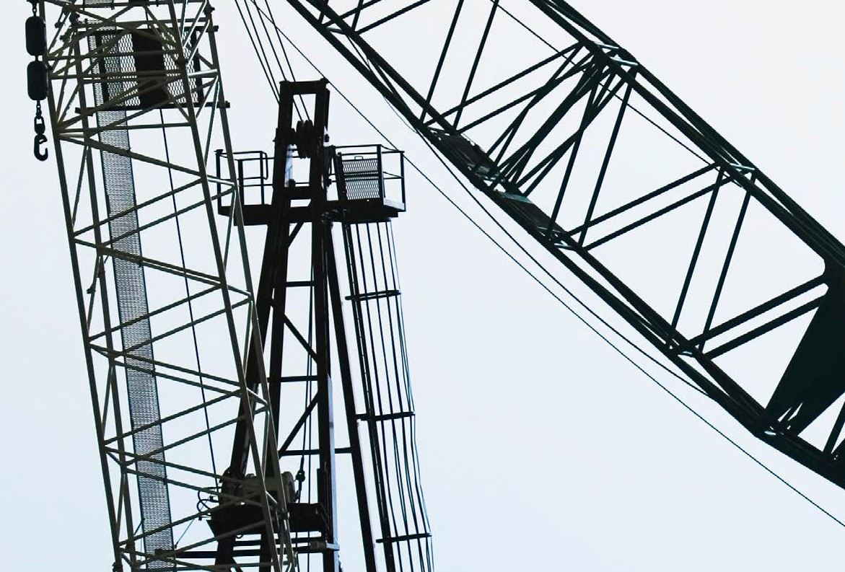

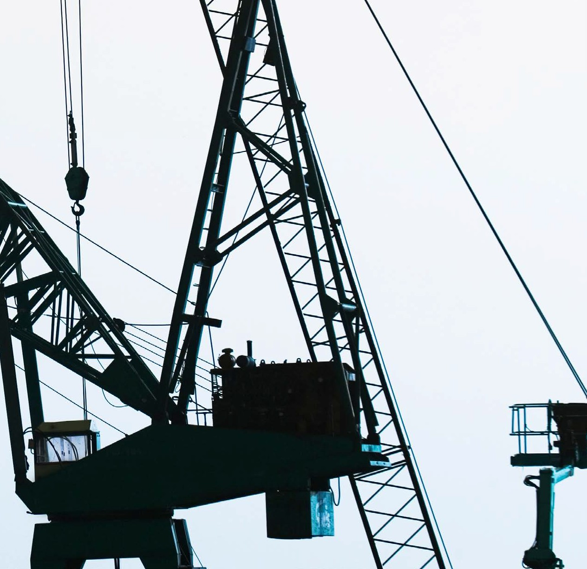Trust the foundation

Michael Burnham5, the author of Targeting Zero, states, “to be trusted, all you have to do is what you say you are going to do.”

He also asks, “How important is trust for a leader?

It is the most important thing. Trust is the foundation of leadership. It is the glue that holds an organisation together. Leaders cannot repeatedly break trust with people and continue to influence them. It just doesn’t happen.”

The challenge is to establish trust throughout the organisation. Communicating directly with people across all levels of an organisation provides the broadest range of information but also avoids the risk of groupthink, which can lead to irrational or dysfunctional decision-making. In any broad-ranging conversation executives must be prepared to face criticism. In some ways, criticism should be encouraged as it can often be the most important catalyst to safety improvements.

This is all part of trusting the workforce and, in return, generating trust in executives.

5 Targeting Zero, April 2015, Professional Safety, The journal of the American Society of Safety Engineers

8 **|**

As long ago as 1993, David Borys an independent safety educator and researcher stated, “Organisations with a positive safety culture are characterised **by communications founded on mutual trust**, by shared perceptions of the importance of safety and by confidence in the efficacy of preventive measures.”6

**Case study**

A global construction client is paying particular focus on building trust between its workforce and its leaders as well as between its people and the company. Trust requires much attention, commitment and self-reflection. This organisation has found that trust takes a long time to build, and one small comment or action can throw a lot of hard work out the window. The only way to achieve a work environment that positively contributes is to have it built on trust.

6 Borys. D., (2014). Organisational Culture. In Safety Institute of Australia, The Core Body of Knowledge for Generalist OHS Professionals. Tullamarine, VIC. Safety Institute of Australia.

## What must change

Words are important. The most obvious manifestation of the Plus One approach to safety is changing how we talk about safety and how our people think about workplace health and safety. An easy example of this is to redefine safety from being based on negatives to positives. For instance, if your company has had one percent of your workforce injured in a month, this means that 99 percent worked without injury. EY’s Nicole Ashcroft acknowledges that this is new thinking and can be disorienting but that industry needs to create case studies that show the theory becoming practice.

As part of the Plus One approach, people will begin to see an acknowledgement of their efforts and will be more encouraged, responsive and participatory. The positives will, often unconsciously, begin to appear in normal everyday conversations without the need to introduce such issues through formalised training. Plus One thinking will, as a result, be seen as more valid and originating from the people rather than from an imposed strategy. In John Green’s words people will start to feel part of the solution.

Companies can reflect the Plus One approach in formal documents which reinforce to stakeholders that the executive is serious about looking at safety anew.

In 2015 the Australian Civil Aircraft Safety Authority was presented with a Work Health and Safety Reporting Award. Safe Work Australia’s Chief Executive Officer, Michelle Baxter, said, “It is important to report on how companies manage health and safety to not only differentiate yourself but to demonstrate to others how health and safety can be integrated within a business”.

She believes that, “By including high quality work health and safety information in your annual report, you can establish your organisation as a leader in work health and safety, one in which work health and safety is not an ‘add on’, but integrated into business decisions and processes.”7

This award, part of the Australasian Reporting Awards, shows the importance of not just applying safety in a new way but publicly and officially stating that safety is managed differently in this business. The need to continue to report on the frequency of lost time injuries or other traditional metrics will be required for some time but more and more people, regulators, investors and stakeholders are looking to measure a company’s worth using these new leading performance indicators.

7 <http://www.safeworkaustralia.gov.au/sites/swa/media-events/media-releases/pages/> mr18062015

## Looking ahead

In many workplaces safety is managed as a separate process, largely disconnected from the business imperatives of production and profit. However, health and safety is not a process in its own right, but an outcome of business decisions, strategy, culture and performance.

Plus One can help break safety out of the traditional artificial confinements. It allows you to consider all the elements of business operations that could impact worker and client safety. It does this through changing words and changing the thoughts behind those words.

Executives and corporate leaders must be open to this new safety perspective in order for safety decisions to be contemporary and, hopefully, inspiring. These decisions may not always be right but the preparedness to be wrong and to learn from these errors is integral to the new safety perspective.

Health and safety management must keep progressing and improving and this requires change; it also requires risky decisions but the risk of error can be minimised when safety change is anticipated and embraced.

Modern companies that move towards Plus One demonstrate that they are prepared to think creatively.

### By changing how we talk about health and safety and shifting to positive language, we can influence how people feel.

**The future of health and safety** Moving beyond zero **|** 9

## Further Reading

Professor Erik Hollnagel, *Safety I and Safety II*

Sidney Dekker, *Safety Differently*

Michael Burnham, *Targeting Zero*

Dr Rod Gutierrez, *What lies beyond zero? A new approach to health & safety*

Dr David Borys, *Organisational Culture*

Dr Sharron O’Neill, *The Business Case for Safe, Healthy & Productive Work — Implications for resource allocation: Procurement, Contracting and infrastructure decisions*

10



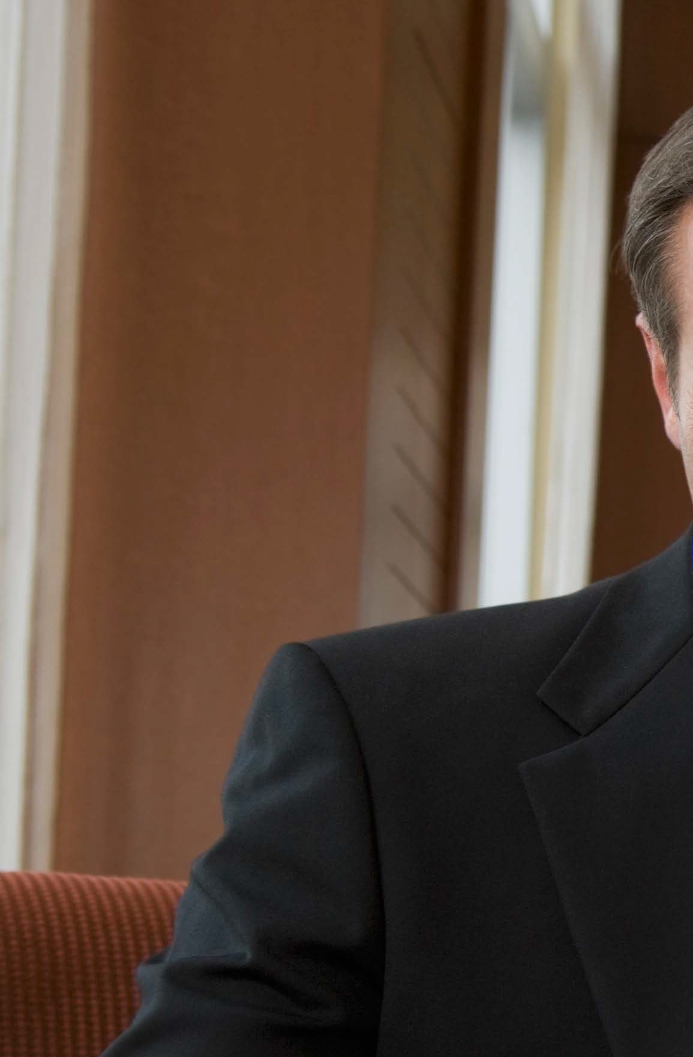



**The future of health and safety** Moving beyond zero **|** 11

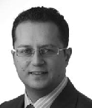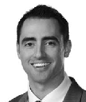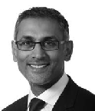

To discuss further please contact your EY adviser or one of the HSE Leaders below:

Mathew Nelson

Asia-Pacific Managing Partner, Climate Change and Sustainability Services Tel: +61 3 9288 8121

[mathew.nelson@au.ey.com](mailto:mathew.nelson@au.ey.com)

Dr. Matthew Bell

Oceania Leader, Climate Change and Sustainability Services

Tel: +61 (0) 411 647 114

[matthew.bell@au.ey.com](mailto:matthew.bell@au.ey.com)

Andi Csontos

HSE Partner, Climate Change and Sustainability Services Tel: +61 2 9248 4642

[andi.csontos@au.ey.com](mailto:andi.csontos@au.ey.com)

Terence Jeyaretnam

Markets Partner, Climate Change and Sustainability Services

Tel: +61 3 9288 8291

[terence.jeyaretnam@au.ey.com](mailto:terence.jeyaretnam@au.ey.com)

EY | Assurance | Tax | Transactions | Advisory

About EY

EY is a global leader in assurance, tax, transaction and advisory services. The insights and quality services we deliver help build trust and confidence in the capital markets and in economies the world over. We develop outstanding leaders who team to deliver on our promises to all of our stakeholders. In so doing, we play a critical role in building a better working world for our people, for our clients and for our communities.

EY refers to the global organisation, and may refer to one or more, of the member firms of Ernst & Young Global Limited, each of which is a separate legal entity. Ernst & Young Global Limited, a UK company limited by guarantee, does not provide services to clients. For more information about our organisation, please visit ey.com.

About EY’s Climate Change and Sustainability Services

Governments and organizations around the world

are increasingly focusing on the environmental, social and economic impacts of climate change and the drive for sustainability.

Your business may face new regulatory requirements

and rising stakeholder concerns. There may be opportunities for cost reduction and revenue generation. Embedding a sustainable approach into core business activities could

be a complex transformation to create long-term shareholder value.

The industry and countries in which you operate as well as your extended business relationships introduce specific challenges, responsibilities and opportunities.

Our global, multidisciplinary team combines our experience in assurance, tax, transactions and advisory services with climate change and sustainability knowledge and experience in your industry. You’ll receive tailored service supported by global methodologies to address issues relating to your specific needs. Wherever you are in the world, EY can provide the right professionals to support you in reaching your sustainability goals.

© 2016 Ernst & Young, Australia. All Rights Reserved.

APAC No. AUNZ00000612 M1629035

ED NONE

This communication provides general information which is current at the time of production. The information contained in this communication does not constitute advice and should not be relied on as such. Professional advice should be sought prior to any action being taken in reliance on any of the information. Ernst & Young disclaims all responsibility and liability (including, without limitation, for any direct or indirect or consequential costs, loss or damage or loss of profits) arising from anything done or omitted to be done by any party in reliance, whether wholly or partially, on any of the information. Any party that relies on the information does so at its own risk. The views expressed in this article are the views of the author, not Ernst & Young. Liability limited by a scheme approved under Professional Standards Legislation.

ey.com